**Ministry of Higher Education and Scientific Research**

**University of Baghdad**

**Institute of Laser for Postgraduate Studies**

**Assessment of Retinal Nerve Fiber Layer by OCT imaging following**

**Nd: YAG Laser Capsulotomy**

A Dissertation Submitted to the Institute of Laser for Postgraduate Studies, University of Baghdad in Partial Fulfillment of the Requirements for the Degree of Higher Diploma in Laser in Medicine - Ophthalmology

BY

**Husain Jasim Abed Al-Khafaji**

M.B.Ch.B., C.A.B. Ophth.

Supervisor

Ophthalmic Specialist

**Ahmed M. Hasan Abdulaziz**

**M.B.Ch.B., C.A.B. Ophth , D.L**

**1440 AH 2018 AD**

**بسم الله الرحمن الرحيم**

**)) نرفع’دَرجتٍ من نشاءُ وَفوَق كل ذي علمٍ عليم ((**

**صدق الله العلي العظيم**

**يوسف / الآية 76**

**Certification**

I certify that this thesis was prepared under my supervision at the Institute of Laser for Postgraduate studies, University of Baghdad.as a partial fulfillment of requirements for the degree of "Higher Diploma in Laser in Medicine - Ophthalmology.

Signature:

Name: Dr.Ahmed M. Hasan Abdul-Aziz

Title: Lecturer

Address: Institute of Laser for Postgraduate studies, University of Baghdad.

Date: / / 2018

(Supervisor)

In view of the available recommendation, I forward this thesis for debate by Examining Committee.

Signature:

Name: Dr. Shelan Khasro Tawfeeq

Title: Asst. Professor

Address: Head of the scientific committee/ Institute of Laser for Postgraduate studies, University of Baghdad.

Date: / / 2018

**Dedication**

**To my mother, who was learn life for me**

**To my wife W. Ahmad, daughters and family**

Hussein

**Examination Committee Certification**

We certify that we have read this dissertation " **Assessment of Retinal Nerve Fiber Layer by OCT imaging following Nd: YAG Laser Capsulotomy** " and as Examination Committee, we examined the student in its content and in our opinion, it is adequate with standards as a dissertation for a degree of Higher Diploma in Laser in Medicine / Ophthalmology.

**Signature:**

**Name:** **Dr. Mohamed Hamza Ahmed**

**Title:** Ophthalmic Specialist

**Address:** Ibn Al Haitham Ophthalmic

Teaching Hospital

**Date:** / 12 / 2018

(Member)

**Signature**:

**Name:** **Dr. Hussein Ali Jawad** **PhD.**

**Title:** Assistant Professor

**Address**: Institute of Laser for Postgraduate Studies,

University of Baghdad

**Date**: / 12 / 2018

(Member)

Approval by Deanship of Institute of Laser for

**Signature:**

**Name**: **Prof. Dr. Abdual Hadi M. Al-Janabi.**

**Title**: Dean

**Address:** Institute of Laser for Postgraduate Studies, University of Baghdad.

**Date**: / / 2018

**Acknowledgements**

Thanks God who granted me this chance to extend my utmost appreciation and for giving me power and support to finish this work.

I would like to express my deep gratitude and appreciation to **Prof. Dr. Abdual Hadi M. Al-Janabi,** Dean of the Institute of Laser for Postgraduate Studies, for his encouragement, help, and his support during the study and research work.

Great respect to **Dr. Ahmed M. Hasan Abdul-Aziz**, Ophthalmic & Laser Specialist; Institute of Laser for Postgraduate Studies, University of Baghdad for his supervision, help and cooperation.

I would like to express my deepest appreciation and full thanks to **Dr. Layla Mohammed Hassan** / Institute of Laser for Postgraduate Studies, University of Baghdad for his advice, guidance, helpful suggestion and encouragement that he gave during this work.

I would like to express my deepest appreciation and full thanks to **Asst. Prof. Dr. Ali Shuker Mahmoud** / Institute of Laser for Postgraduate Studies, University of Baghdad for his advice, guidance, helpful suggestion and encouragement that he gave during this work.

My thanks extended to the **Staff of Al-Habobi Teaching Hospital in Nassiryah** and to the staff of Institute of Laser for Postgraduate Studies for their help and cooperation during this study.

**i**

**Abstract**

**Introduction**

Posterior capsule opacification is one of the most common post cataract surgery complications especially in young patient which mean thickening of posterior lens capsule due to proliferation of original crystaline lens cells leading to decrease in visual acuity and contrast sensitivity.

Nd: YAG laser posterior capsulotomy performed in order to make hole in the posterior capsule to permit light to reach the retina in other word to clear the visual axis and improve visual acuity.

**Objective**

This study is conducted with view to assessment the significance of retinal nerve fibers layer thickness changes by using Optical Coherent Tomography in pseudophakic eye patients’ pre and one month period Nd: YAG laser posterior capsulotomy performed.

**Patients and method**

The measurement thickness of retinal nerve fiber layer by optical coherent tomography to a twenty one eyes of twenty one pseudophakic patients, therteen males and eight females with age range from 42 to 74 years old and pre Nd: YAG laser (1064 nm) capsulotomy and post of it for period of one months.from the 20th of June 2018, till the 20 of September 2018 .

This is sudy done in AL-Habobi teaching Hospital in Nassiryah During this period, All patients after a period more than 6 months duration post cataract surgery with visually affected posterior capsule opacification and IOP within normal range (14-21 mmHg). In this sample the patient with history of ophthalmic and retinal disease excluded like Diabetic retinopathy, glaucoma,retinal vascular diseases and congenital retinal diseases

**ii**

**Results**

Assessment of retinal nerve fibers layers thickness pre and after one month post capsulotomy ,the retinal nerve fibers layers thickness values increase about 5 μm in average post capsulotomy and the Phacoemulsification patients had a better results than Extracapsular cataract extraction patients regarding post Nd:YAG laser capsulotomy vision and this attributed to lesser post-operative astigmatism and better optical coherent tomography signal quality .

**Conclusion**

The posterior capsule opacification is common after cataract surgery.It is lead to underestimation of retinal nerve fiber layer thickness when it measured by OCT is mostly related to decrease light entrance to the globe due to opacity in the capsule.

**iii**

**Contents**

**Abstract i**

**List of contents iv**

**List of figures vi**

**List of tables vii**

**Abbreviation viii**

**iv**

**LIST OF CONTENT**

**CHAPTER ONE/** **INTRODUCTION AND BASIC CONCEPTS**

**Subject page No.**

1.1- The eye ball 1

1.1.1- Anterior segment 2 1.1.2- Posterior segment 3

1.1.3.Retinal layers 4

1.2- cataract 5

1.3- Posterior capsular opacification 6

1.3.1- incidence and pathogenesis 7-8

1.3.2- Neodymium: Yttrium–Aluminum Garnet Laser (1064 nm) Posterior Capsulotomy 9

1.4- Laser basics 10

1.4.1- laser components 10-11

1.4.2- Lasing action 12-13

1.4.3- properties of laser light 14

1.5- Optical Coherent Tomography 14

1.5.1 Physical principles of OCT 14-16

1.6-tissues Laser Interactions 17

1.6.1- Wavelength dependent mechanisms 18-21

1.6.2- Wavelength independent mechanisms 22-23

1.7 Literature review 23-24

1-8 Aim of the work 24

**v**

***CHAPTER TWO/MATERIALS AND METHODS***

**Subject page No.**

2.1- Patients 25

2.2- equipements use in this study 26

2.2.1 Laser system specification 26-27

2.2.2 Optical Coherent Tomography 28-29

2.3- Methods 30

2.3.1- Criteria of treatment 30

2.3.2- Explanation to the patient 30

2.3.3- Pretreatment ocular examination 30

2.3.4- procedure technique 31

2.3.5- Laser system checking 31

2.3.6- Treatment tips 32

2.3.7- Post operative follow up 32

2.3.8- Complications 32

2.3.9- Laser safety in work 33-34

***CHAPTER THREE/RESULTS AND DISCUSSION***

**Subject page No.**

3.2- Effect of Nd: YAG laser capsulotomy on RNFL thickness 36

3.1- Results 35-42

**vi**

3.2- Discussion 42

3.2.1- Age of the patients 42

3.2.2- Intra-ocular pressure effect 42

3.2.3- Period of PCO post Cataract surgery 43

3.2.4- Effect of type cataract surgery on RNFL thickness post Nd:YAG 1064nm laser capsulotomy treatment 43

3.4.5- Effect of Nd:YAG 1064 nm laser capsulotomy treatment on RNFL thickness 43

3.3- Conclusions 44

3.4 Recommendations 45

References 46

**LIST OF FIGURES**

Fig ( 1.1) anatomy of the eye 3

Fig ( 1.2 ) anterior segment anatomy of the eye 4

Fig ( 1.3) retinal anatomy of the eye 5

Fig (1-4) eye with cataract 6

Fig (1.5) Posterior capsular opacification 7

Fig (1- 6) Nd:YAG Laser capsulotomy 10

Fig (1.7) Laser components 11

Fig. (1.8) Full-field OCT optical setup 16

Figure (1.9) Laser tissue interaction mechanisms 17

Fig ( 1.10 ) Laser tissue interaction chart 18

**vii**

Fig (1.11) Thermal effects of laser radiation 21

Fig (2.1)Nd:YAG 1064 nm laser system( Nidek YC 1400) 26

Fig (2.3) ZEISS (CIRRUS HD-OCT) Advancing smart OCT 28

Fig (2.4) CIRRUS HD-OCT - Optical Coherence Tomography results 28

Fig. (3-1) Post-operative period till capsulotomy 36

Fig (3-2) Average of IOP increase after laser capsulotomy 40

Fig (3-3) Average of RENFL thickness increase after laser capsulotomy 40

**List of tables**

Table (1-1) laser thermal effect on the tissue 20

Table (2-1) Laser system specifications 27

Table (2-2) Specifications of OCT machine 29

Table (3.1) eye distribution according to type of surgery surgery 35

Table (3-2) the age distribution according to sex 36

Table (3-3) details of sample 37

Table (3-4) details of sample pre&post capsulotomy RNFL thickness,spherical equivalent &VA 38

Table (3-5) RNFL thickness and energy 41

**viii**

**Abbreviation**

Nd Neodymium

YAG Yttrium—Aluminum-Garnet

PCO Posterior capsule opacification

RNFL Retinal nerve fibers layer

OCT Optical Coherent Tomography

TD-OCT Time domain Optical Coherent Tomography

FD-OCT Fourier domain Optical Coherent Tomography

Phaco Phacoemulsification

ECCE Extracapsular cataract extraction

IOL Intraocular lens

ARMD age-related macular degeneration

PMMA Polymethylmethacrylate

IOP Intraocular pressure

VA Visual acuity

BCVA Best corrected visual acuity

D Diopter

mmHg millimeter mercury

UV ultr-violet

PC-IOL posterior chamber intraocular lens

RD Retinal detachment

CME cystoids macular edema

ix

Cm centimeter

λ wave length

IR Infra-red

°c Centigrade

mm Millimeter

ml Milliliter

gm Milligram

ms millisecond

ns nanosecond

ps picosecond

fs femtosecond

mj Mili-Joul

mW Mili-Watt

Hz Hertz

µm Micrometer

**CHAPTER ONE**

**INTRODUCTION AND BASIC CONCEPTS**

**1**

* 1. **– THE EYE BALL:**

The eyeball (Fig. 1.1) is a homogenous cyst structure kept distended by the fluid pressure inside it. Although, generally referred to as a globe, the eyeball is not a sphere but an ablate spheroid. The central point on the maximal convexities of the anterior and posterior curvatures of the eyeball is called the anterior and posterior pole, respectively. The equator of the eyeball lies at the mid plane between the two poles.

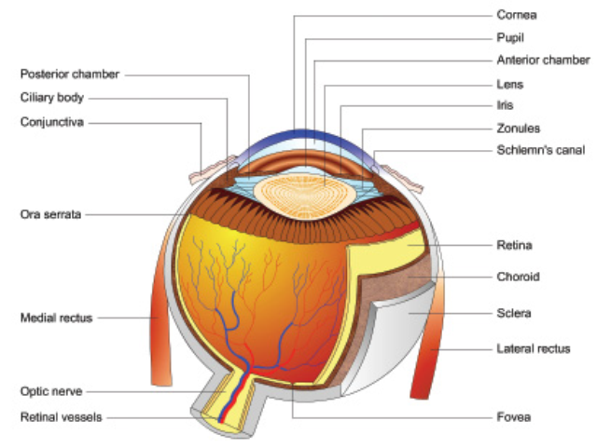

Fig (1.1) anatomy of the eye [1]

**2**

**Dimensions of an adult eyeball**

1. Anteroposterior diameter 24 mm
2. Horizontal diameter 23.5 mm
3. Vertical diameter 23 mm
4. Circumference 75 mm
5. Volume 6.5 ml
6. Weight 7 gm

**Coats of the eyeball**

The eyeball comprises three coats: outer (fibrous coat), middle (vascular coat) and inner (nervous coat).

**1.** Fibrous coat. It is a dense strong wall which protects the intraocular contents. Anterior 1/6th of this fibrous coat is transparent and is called cornea. Posterior 5/6th opaque part is called sclera. Cornea is set into sclera like a watch glass. Junction of the cornea and sclera is called limbus. Conjunctiva is firmly attached at the limbus. [1]

**2.** Vascular coat (uveal tissue). It supplies nutrition to the various structures of the eyeball. It consists of three parts which from anterior to posterior are : iris, ciliary body and choroid.

**3.** Nervous coat (retina). It is concerned with visual functions. Segments and chambers of the eyeball. [1]

**4.** Optic nerve

**5.** Crystaline Lens

**3**

**6.** Vitreous body and Aqueous humour

**7.** Nerves, Vessels, Musscles, Fat

**The eyeball can be divided into two segments: anterior and posterior.**

**1.1.1.Anterior segment**. It includes crystalline lens (which is suspended from the ciliary body by zonules), and structures anterior to it iris, cornea and two aqueous humour-filled spaces: anterior and posterior chambers. See (Fig. 1.2)

1. Anterior chamber. It is bounded anteriorly by the back of cornea, and posteriorly by the iris and part of ciliary body. The anterior chamber is about 2.5 mm deep in the centre in normal adults. It is shallower in hypermetropes and deeper in myopes, but is almost equal in the two eyes of the same individual. It contains about 0.25 ml of the aqueous humour.
2. Posterior chamber. It is a triangular space containing 0.06 ml of aqueous humour. It is bounded anteriorly by the posterior surface of iris and part of ciliary body, posteriorly by the crystalline lens and its zonules, and laterally by the ciliary body.

**1.1.2. Posterior segment**. It includes the structures

posterior to lens, vitreous humour (a gel like material which fills the space behind the lens), retina, choroid and optic disc.

**4**

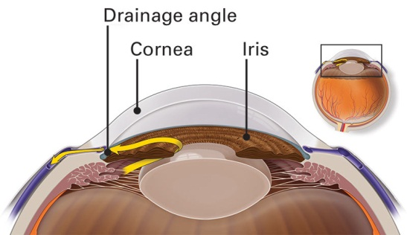

Fig (1.2) anterior segment anatomy of the eye [2]

**1.1.3 Retinal layers**

The retina is sensitive film of the eye which composed from special modified cells convert the light signal to electrical signal and transmits it to the brain through the optic nerve. It composed from ten layers. See (Fig. 1.3)

1. Retinal pigment epithelial layer.

2, photoreceptor layer.

3. External limiting membrane.

4. Outer nuclear layer.

5. Outer plexiform layer.

6. Inner nuclear layer.

7. Inner plexiform layer.

8. Ganglion cell layer.

9. Nerve fiber layer.

10. Internal limiting membrane. [2]

**5**

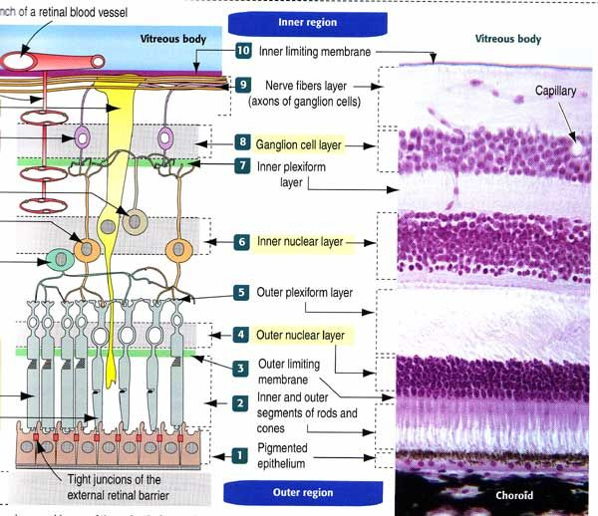

Fig (1.3) retinal anatomy of the eye [2]

**1.2. Cataract**

Cataract define is opacification of the lens of the eye due to changes in lens proteins is the commonest cause of treatable blindness in the world. See (Fig. 1.4).The large majority of cataracts occur in older age as a result of the cumulative exposure to environmental and other influences such as smoking,

**6**

UV radiation and elevated blood sugar levels. This is sometimes referred to as age-related cataract. A smaller number are associated with specific ocular or systemic disease and defined Physico-chemical mechanisms. Some are congenital and may be inherited. Although much effort has been directed towards slowing progression or preventing cataract, management remains surgical. The operation involves removal of most of the lens and its replacement optically by artificial IOL implant. Through an extended incision at the periphery of the cornea or anterior sclera followed by extra-capsular cataract extraction (ECCE). The incision must be sutured. Or by liquefaction of the lens using an ultrasound probe introduced through a smaller incision in the cornea or anterior sclera (phacoemulsification). Usually no suture is required. This is now the preferred method in the world. [1]



Fig (1-4) eye with cataract [3]

**7**

**1.3- Posterior capsular opacification:**

Visually significant posterior lens capsular opacification (PCO), also known as ‘after cataract’, is the most common late complication of uncomplicated cataract surgery, historically occurring eventually in up to 50% of patients. It is caused by the proliferation of lens epithelial cells that have remained within the capsular bag

following cataract extraction. The incidence of PCO is reduced when the capsulorhexis opening is in complete contact with the anterior surface of the IOL. PMMA (and probably to a lesser extent hydrogel) IOLs are particularly prone to PCO, but otherwise implant design is more important than material; a square optic edge appears to inhibit PCO [3]

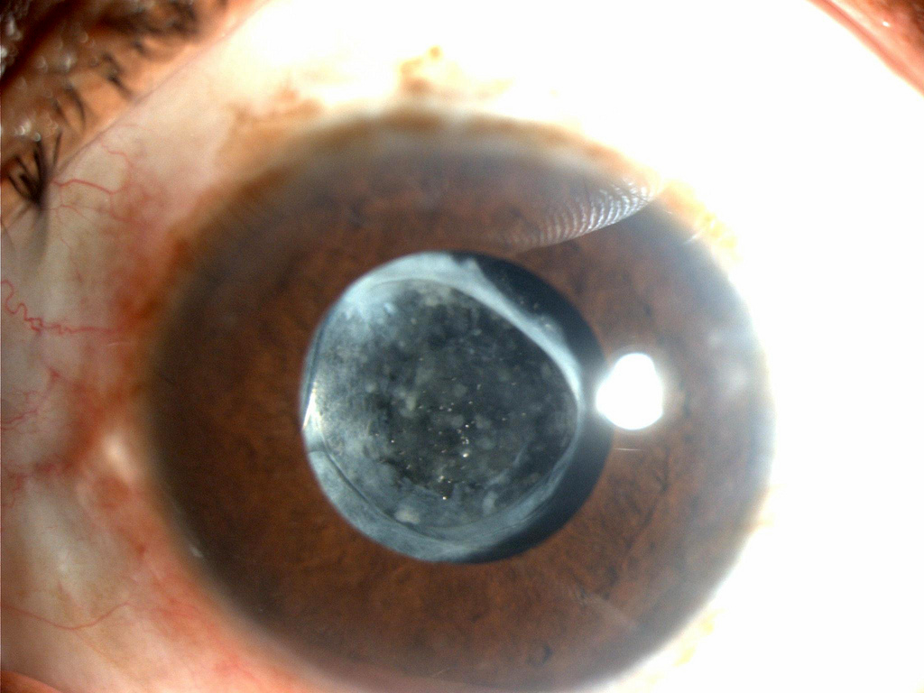

Fig (1.5) Posterior capsular opacification [4]

**8**

**1.3.1- incidence and pathogenesis:**

Postoperative opacification of initially clear posterior capsules occurs frequently in patients after cataract surgery, although the time to opacification is highly variable. In adults, the time from surgery to visually significant opacification varies from months to years, and the rate of opacification declines with increasing age. In younger age groups, almost 100% opacification occurs within 2 years after surgery.

*The incidence of posterior capsule op*acification varies with different studies. Rates have been reported as 10-56% at 3 years with differing lens materials. Several studies have reported that the incidence of posterior capsule

opacification is lower if meticulous cortical cleanup is performed. Hydrophobic acrylic lenses with square lens edge designs have also been found to decrease posterior capsule opacification by decreasing the migration of lens epithelial cells.

Clinically, optical degradation of initially clear posterior capsules takes several forms. Fibrosis or a gray-white band or plaque-like opacity that may be recognized in the early postoperative period or may occur later. Fibrosis that is present in the first days to weeks postoperatively probably more often represents cortical lamellae left at the time of surgery. Fibrosis that develops months to years postoperatively is caused by migration of anterior lens epithelium, fibroblastic metaplasia, and collagen production, Heavy fibrosis occurs frequently at the edge of a PC-IOL placed in the bag with apposition of anterior and posterior capsules.[3]

Formation of small Elschnig pearls and bladder cells, the second major form of opacity, occurs months to years after surgery. This type of opacity occurs from proliferating lens epithelial cells, which can form layers of several cells

**9**

thick .Capsular wrinkling can have two manifestations. Broad undulations of clear capsule are particularly common in the early postoperative period before the capsule becomes tense. Posterior chamber lens haptics may induce these broad wrinkles along the axis of the hepatic orientation. Conversely, a posterior chamber lens may tend to flatten broad wrinkles if the optic body presses on the capsule. Fibrotic contraction can also induce wrinkles. Broad, undulating wrinkles of clear capsule rarely are visually disturbing to the patient; an unusual patient may perceive linear distortion or shadows that correspond to the wrinkles, which are relieved by capsulotomy. In contrast, fine wrinkles or folds in the capsule, caused by myoblast differentiation can result in marked optical disturbance. These fine wrinkles are caused by

myofibroblastic differentiation on the migrating lens epithelial cells, which acquire contractile properties, resulting in the wrinkles. [4]

**1.3.2- Neodymium: Yttrium–Aluminum Garnet Laser (1064 nm) Posterior Capsulotomy:**

Nd: YAG Laser (1064 nm) Posterior capsulotomy is a procedure to creation of an opening in the posterior capsule with the Nd: YAG laser.[4] The rate of Nd: YAG capsulotomy is reported to be decreasing with the use of modern lens

designs. [5] The rates of capsulotomy have fallen to 0.9-17% compared with the rate of 20-33% in the 1980s and early 1990s. Failure of vision to improve following Nd:YAG laser posterior capsulotomy is frequently due to preexisting ocular disease, including age-related macular degeneration (ARMD), CME, other macular disease, RD, glaucoma, ischemic and optic neuropathy [6]

**10**

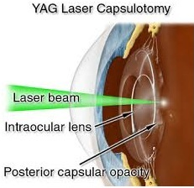

Fig (1- 6) Nd:YAG Laser capsulotomy[6]

**1.4- Laser basics:**

**1.5.1- laser components:**

Lasers have three basic physical components regardless of style, size, or application as shown in figure 1.7.

**A-Pumping source:** the energy source provides the excitation mechanism for pumping and focusing the molecules in an active medium. These energy sources can include electrical discharges, chemical reactions, and high-powered light sources (flash lamps).

**B-Active medium:** laser light is generated in an active medium which can be solid crystals such as Ruby or Nd: YAG, liquid dyes, gases like carbon dioxide or semiconductors such as Diode. Only certain types of media have the necessary optical, mechanical, atomic, and / or molecular characteristics to

**11**

make laser activity possible. The excitation of the active medium can be done with a variety of energy sources. These power sources elevate the molecules in the active medium to an energetic or exited state and create a condition known as population inversion. This condition occurs when energy is poured into the active medium so rapidly that most of its molecules absorb excess energy. Once this excited state is reached, the molecules are primed to have this energy amplified and released. [6]

**C-Resonant cavity:** the resonant cavity is the area in the laser where theprimary laser activity occurs. The main housing in the laser consists of two mirrors placed on either end. The space between these two mirrors is filled with excited molecules from the active medium. This space is called the resonant cavity because photons produced by the energized medium bounce back and forth between the mirrors becoming more amplified. One of the mirrors is only partially transmitive which reflect less than 100% of the laser light and transmits the reminder, while the other mirror is high reflectance which reflects essentially 100% of the laser light. [7]

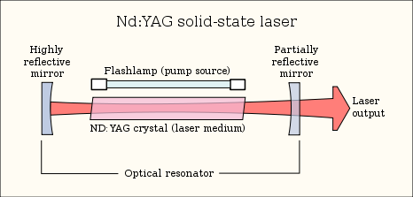

*Fig (1.7) Laser components* [7]

**12**

**1.4.2- Lasing action:**

All atoms are stable in their lowest energy state, Known as the ground state. Energy is delivered to atoms in a laser active medium by a process called pumping. The absorption of energy by an atom elevates its electrons from their ground state to a higher energy level. One of these, the upper laser energy level, allows excited atoms to accumulate there. When there are more atoms in the excited than in the lower energy level, population inversion is said to have occurred. Atoms in the excited state are unstable and their electrons tend to spontaneously return to the ground state by emitting light energy. This spontaneous emission of light is incoherent and it travels in all directions. Atoms are less stable in the lower laser energy state, and can drop back to the ground state and enter the cycle anew. [6]

If an atom at a higher energy level is stimulated further by a photon whose wavelength is that which the atom would naturally emit, the resulting emission will be coherent with the stimulating photon, and the atom will drop to a lower

energy level. Most of the energy released by the active medium is incoherent spontaneous emission, but the small amount released by stimulated emission can be amplified.[7]

The active laser medium is housed in a tube which has a mirror at each end. The distance between the mirrors must equal a multiple of the wavelengths of the light emitted so that resonance can occur. When a photon encounters an excited electron and stimulated emission occurs, the light emitted travels down the tube, and is reflected and rereflected at both mirrors. Because the mirrors are precisely aligned and a whole number of wavelengths

**13**

apart, the light which has traversed the tube is still exactly in phase with itself on its second and subsequent exactly in phase with itself on its second and subsequent journeys. Thus it reinforces itself. This is known as *resonance*. Meanwhile other stimulated emissions are taking place so that the light traversing the tube gets stronger and stronger while remaining exactly in phase (coherent) and the lasing process is under way. If one of the mirrors is made partially transparent, some of the light may be allowed to leave the tube. [8]

**1.4.3- properties of laser light:**

Although lasers vary in size and intensity, all lasers light have fundamental characteristics, which distinguish it from natural light.

There are three distinctive features of laser beam:-

1. **Coherence;** this means that all waves train in laser beam are exactly in phase with each other.
2. **Collimation (Directionality);** this indicates that all rays of laser beam are relatively parallel over a long distance. Beam is very narrow & can travel to long distances without spreading.
3. **Monochromatic;** this indicates that all individual wave trains have the same wavelength and frequency (narrow spectral band of radiation). In medical systems, and in most clinical applications, the bandwidth of the output beam is so small to be negligible, and these lasers can reasonably be referred to as operating at almost single wavelength or monochromatic.

**14**

**D-High Intensity;** You know that the intensity of a wave is the energy per unit time flowing through a unit normal area. In an ordinary light source, the light spreads out uniformly in all directions. If you look at a 100 Watt lamp filament from a distance of 30 cm, the power entering your eye is less than 1/1000 of a watt. In laser, the light spreads in small region of space and in a small wavelength range. Hence, laser light has greater intensity when compared to the ordinary light.[7]

**1.5- Optical Coherent Tomography:-**

Optical coherence tomography (OCT) is a new imaging modality, used for the first time by Huang et al. in 1991 in vitro on the human peripapillary region of the retina and coronary arteries . OCT is based on near infrared light; an optical beam is directed at the tissues, most of the light scatters and only the small portion of this light that reflects from subsurface features is collected and forms the image by yielding spatial information about tissue microstructure. The critical advantage of OCT over ultrasonography and magnetic resonance imaging is due to its micrometer resolution (about 10–15 μm of tissue axial resolution)[8]

**1.5.1 Physical principles of OCT**

OCT uses low coherent near infrared light. The wavelength used is around 1300 nm to minimize energy absorption in the light beam caused by protein, water, haemoglobin and lipids. The physics principle that allows the filtering of scattered light is optical coherence a light source emits a low-coherence, laser light wave. The light wave reaches a beam splitter or a partial mirror, which splits the light wave in half. One part of the light wave travels to a reference mirror, where it reflects directly back towards the beam splitter. The

**15**

second part travels to the sample tissue. Depending on the optical properties of the tissue, some amount of light may be absorbed, refracted or reflected. Reflection occurs when there is a region of sharp refractive index mismatch; therefore the velocity of light is not considered constant when it passes through different media. Light travels faster in a medium of low refractive index compared to a medium of high refractive index. The amount of reflection depends on the level of mismatch, the angle and the polarization of the incident angle. The reflected portion of the light travels back towards the

beam splitter, where it meets with the reference light wave. The interaction between these two light waves is the basis on which OCT produces images. When two light waves of the same wavelength and constant phase difference meet, they are combined through superposition; this phenomenon is called interference. If the light waves are in phase, they add together in constructive interference; if they are out of phase, they cancel each other out in destructive interference. When the sample and reference light waves meet, they either intensify or diminish depending on how the sample light interacts with the tissue. A detector uses the light or dark pattern produced to create a pixel for that specific region. OCT cross-sectional imaging is achieved by performing successive axial measurements of back-reflected light at different transverse positions. After scanning a whole area, a full image of the tissue may be produced.[9]

The major limitation of intracoronary OCT is blood attenuation due to the backscattering properties of red blood cells, thus we need to displace blood from the field of view.

There are two OCT systems: the first-generation system or time domain OCT and the new-generation system or Fourier domain OCT. [9]

**16**

**Time domain OCT**

Time domain OCT (TD-OCT) The pullback speed of TD-OCT ranges between 1 and 5 mm/s. TD-OCT uses a broadband light source containing a moving mirror that allows scanning of each depth position in the image, pixel by pixel. This mechanical scanning process limits the rate at which images can be acquired.

**Fourier domain OCT**

The development of the new-generation or Fourier domain OCT (FD-OCT) enables high-speed pullbacks (10–25 mm/second) during image acquisition.FD-OCT uses a wavelength-swept laser as the light source and the

reference mirror is fixed. This change in technology results in a better signal-to-noise ratio and faster sweeps, allowing a dramatically faster image acquisition and pullback speed than TD-OCT. Presently, the maximum imaging speed that can be achieved with FD-OCT is limited by digital data transfer and storage. [10]

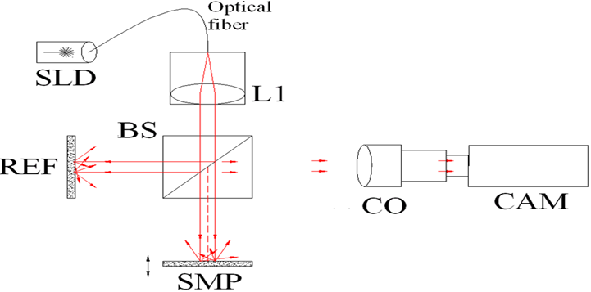

Fig. (1.8) Full-field OCT optical setup [10]

**17**

**1.6- Laser Tissues Interactions**

The possible laser tissue interaction mechanisms are summarizes in figure

Photochemical Photodynamic

therapy

Biostimulation

(Volume stress)

a- λ Dependent Photoablation

(Thermal stress)

Photocoagulation

Photo thermal Photovaporization

Melting

Photodisruption

b- λ independent

Plasma induced ablation

*Figure (1.9) Laser tissue interaction mechanisms* [12]

**18**

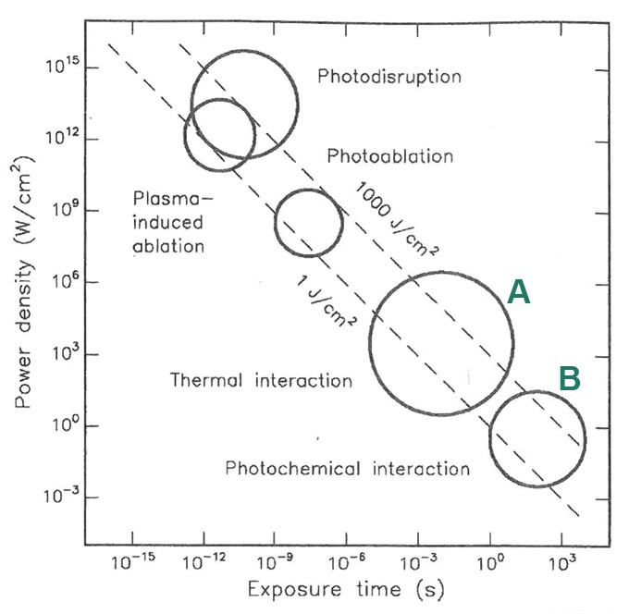

Fig (1.10) Laser tissue interaction chart [12]

**1.6.1- Wavelength dependent mechanisms:**

**A-Photochemical interaction:** By definition, photochemical damage is brought about by photons of such high intrinsic energy (i.e. short wavelength) that chemical bonds of the molecules that compose the tissues are directly broken. Once a bond is broken in a biomolecule, the molecule may change its conformation and thus lose its function. The portion of the molecule, or the functional group, that absorbs the incident photon is termed a chromophore. The electronic transition to the excited state absorbs the energy of the photon, but the decay and release of this energy may proceed by a number of routes.

**19**

One may be the transfer of the energy to break a bond either in the chromophore or elsewhere in the molecule, even sometimes at sites quite remote from the absorption locus. If a covalent bond is broken, each fraction of the molecule may retain one of the shared electrons to become a free radical. These radicals are highly reactive and exist only briefly before they react with neighboring molecules. If the energy in the incident photon can be coupled to the molecule more efficiently, the likelihood of bond breaking is enhanced. This may be done with a vital dye, which is an efficient chromophore that can pass on its trapped energy to bond molecule, thus leading to bond breaking. This process used therapeutically to treat certain tumors. The formation of free radicals is undoubtedly more important in producing tissue damage than the breaking of bonds. Free radicals, such as singlet oxygen, can attack many molecule types and render them ineffective. Photochemical interaction includes.

**.** Photodynamic therapy

. Photochemical ″Photoablation″ (volume stress)

. Biostimulation. . [11]

**B-Photothermal interaction:** The term thermal reaction implies a rise in temperature within the tissues that are damaged. To understand the process, it is necessary to know that is meant by temperature rise and how incident energy can bring this about. Temperature is a measure of the kinetic energy stored through a large population of molecules in their vibration, rotational, and intermolecular motions. This energy comes initially (1) from internal conversions, where excited electronic states decay, releasing energy to vibrational or rotational states, or (2) by direct absorption of incident energy

**20**

into vibrational rotational because there is no photon energy required for bond breaking. Sufficient energy to increase the temperature can come by any route; the penetration depth d is particularly useful when it is necessary to consider how deep into a substrate the radiation is deposited. An increase in temperature is the significant local parameter, the non-specific thermal effect of laser light illustrated in different form on the tissue depending upon duration and peak value of tissue temperature achieved i.e. each one related to certain temperature. The changes are shown in the table 1-1

Table (1-1) laser thermal effect on the tissue[12]

|  |  |
| --- | --- |
| Temperature | Biological effect |
| 37°c | Normal |
| 45°c | Hyperthermia |
| 50°c | Reduction in enzymatic activity and cell immobility |
| 60°c | Denaturation of protein and collagen (coagulation) |
| 80°c | Increase membrane permeability |
| 100°c | Vaporization  Thermal decomposition |
| >150°c | Carbonization |
| >300°c | Melting |

**21**

Photocoagulation, the first established therapeutic laser procedure, is today widely used. In clinical ophthalmological practice, we use argon ion laser (488nm blue, 514.5 green), krypton laser (647nm) and frequency doubled Nd- YAG (532nm). The argon and frequency doubled Nd: YAG lasers can be adapted to a slit lamp, binocular indirect ophthalmoscope or used with endoprobes for endophotocoagulations. Diabetic retinopathy is the most common indication for this type of treatment (52% of the treatments). Others retinal diseases treated with thermal laser are age related macular degeneration, retinal tear, central serious chorioretinopathy, retinal vein occlusion and other retinal vascular diseases. Thermal laser is also used in the treatment of glaucoma. Laser trabeculoplasty, used for most forms of open angle glaucoma, pan retinal photocoagulation therapy for neovascular glaucoma and trans scleral Nd:YAG laser cyclophotocoagulation for therapy-resistant glaucoma.

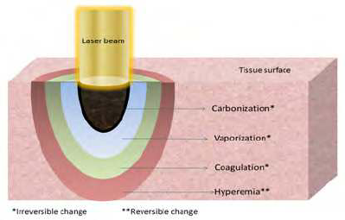

Fig (1.11) Thermal effects of laser radiation [12]

**22**

**1.6.2- Wavelength independent mechanisms:**

1. Plasma induced ablation.
2. Photodisruption.

The spectrum of photodisruptive laser started from pulse duration 500 picoseconds (ps) and shorter. Laser radiation with pulse duration less than 500 ps cause ablation of the tissues by plasma formation without mechanical effects, while in photodisruptive laser, the ablation of the tissues are caused by effects both plasma formation and mechanical distruption.

Plasma formation by nanoseconds (ns) laser has different mechanism and parameters from that caused by ps or femtoseconds (fs) laser.

In ns laser we need higher energy to cause optical breakdown of the tissues by process of thermionic emission which means that the release of free electrons duo to thermal ionization. The additional energy used for plasma formation in ns laser must dissipate in the surrounding tissues, so it is partly converted to shock waves, cavitation, and jet formation.

In ps and fs laser, plasma formation occurs by process of multiphoton ionization which has peak intensities in ultra-short pulses that cause increased local electric filed strength that exceeds the average atomic or intermolecular coulomb electric field providing the necessary condition for plasma ionization. Within 100 ps a very large free electron density with typical volume of 1018 /cm3 is created in the focal volume of the laser beam. The volume of the plasma produced by ps and fs laser is more than two times larger than that of ns, so more energy is required for ionization and vaporization of the matter, hence the amount of energy is no longer contribute in the generation of potential shock waves or cavitation. This is another factor that ps and fs laser not cause mechanical damage. Once formed, the plasma absorbs and scatter

**23**

further incident light. This property shields the underlying structures that are in the beam path. Plasma shielding is important for protection of tissues near treated area, this is especially important in the eye where the retina is considerably protected by the plasma shields during laser surgery of the lens or the vitreous. Shielding effects is related to absorptive and scattering capacity of plasma which is directly related to plasma volume. So in ps and fs laser, large volume of plasma cause more shielding and retinal protection, while in ns laser, small multiple micro-plasmae are produced with less protection, therefore, ps and fs lasers are safer than ns laser and are free from retinal complications [12]

**1.7 Literature review**

Kara N.and Altinkaynak H,in 2012 state that RNFL thickness measured by the Stratus OCT is affected by PCO. RFNL thickness may be underestimated in eyes with preoperative PCO grades higher than 2 and in eyes with preoperative SSs lower than 7.[13]

Jose Javier Garcia-Medina, Monica del Rio-Vellosillo, Vicente Zanon-Moreno, Enrique Santos-Bueso, in 2015 state that OCT quality imaging of RNFL thickness is influenced by PCO. However, no change has been observed after PCO removal in the retinal nerve fibre layer parameters of pseudophakic eyes by reliable examinations before capsulotomy, as measured by OCT.[14]

Cagini C1, Pietrolucci F, Lupidi M, Messina M, confirmed that with old generation TD-OCT, PCO has a strong negative influence on the quality of OCT acquisition, and examination is reliable only when it is possible to

**24**

acquire good quality images. With new generation SD-OCT, tomographic acquisitions are always reliable and are not influenced by the presence of PCO.[15]

Cevher Selim in 2017 state that After Nd: yag laser capsulotomy cyclindrical power refraction and RNFL thickness values significantly change, Average and nasal retinal nerve fiber layer thickness values significantly increase.[16]

**1-8 Aim of the work:-**

This work is conducted with view to determine the significance of changes in RNFL thickness one month after Nd: YAG (1064nm) laser capsulotomy in pseudophakic eye patients by using Optical Coherent Topography.

**CHAPTER TWO**

**MATERIALS AND METHODS**

.

**25**

In this chapter, patient’s preparation and procedure will be illustrated. The laser system used in this work is also discussed. In addition, evaluation criteria, measurements, and implemented safety measures are reviewed.

**2.1- Patients:**

This prospective study was done during a period of Three months, from the 20th of June 2018, till the 20 of September 2018 .In AL-Habobi Teaching Hospital in Nassiryah During this period, twenty one eyes of twenty one Pseudophakic patients for more than 6 months duration post cataract surgery with visually affected posterior capsule opacification and IOP within normal range (14-21 mmHg). In this sample Fifteen male and six females, their age range from 42 to 74 years, thirteen eye had phaco surgery and only eight had ECCE regardless the type of material of IOL or its design (shape).

The patient with history of ophthalmic and retinal disease excluded like Diabetic retinopathy, glaucoma, retinal vascular diseases and congenital retinal diseases

By using short history and meticulous examination. All statistical tests and analyses were based on eyes rather than subjects so that the result could be correlated with those reported by many other investigators.

**26**

**2.2- Equipments Used In This Study:**

|Two main equipements are used in this study the Laser system 1064 nm

Nd: YAG photodisruption (Nidek YC 1400), and Smart Optical Coherent Tomography ZEISS (CIRRUS HD-OCT).

**2.2.1** **Laser system specification**

The laser system used in this work is a 1064 nm Nd: YAG photodisruption (Nidek YC 1400) figure (2.1). The laser specifications are listed in table 2-1[10]

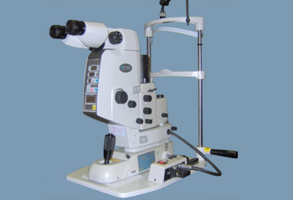

*Fig (2.1) Nd: YAG 1064 nm laser system (Nidek YC 1400) [14]*

**27**

Table 2-1 Laser system specifications [14]

|  |  |
| --- | --- |
| **photodistribution beam** | **Nd- YAG laser**  **Wave length: 1064nm (near IR ivisible)**  **Out put: chopping wave / Q-switching**  **Out put energy: 0.3 – 25 mJ max**  **Pulse duration 7 n sec.**  **Spot size 8 micrometer**  **Cone angle 16o**  **Focus shift 0 -250 micrometer for both anterior and posterior** |
| **Aiming beam** | **Type of laser Laser diode**  **Wavelength 630-680 nm**  **Output powers 5mW**  **Aiming method Dual beam method** |
| **Cooling system** | **Ambient air** |
| **Power requirements** | **Voltage: single phase 120,200,220,240,vac**  **Frequency: 50/60 HZ**  **Power consumption: 1800 VA** |
| **Environmental condition** | **Temperature: 10-30° c**  **No harmful dust and smoke** |
| **Accessories** | **No Accessories** |
| **Delivery system** | **Slit lamp** |

**28**

**2.2.2 Optical Coherent Tomography:-**

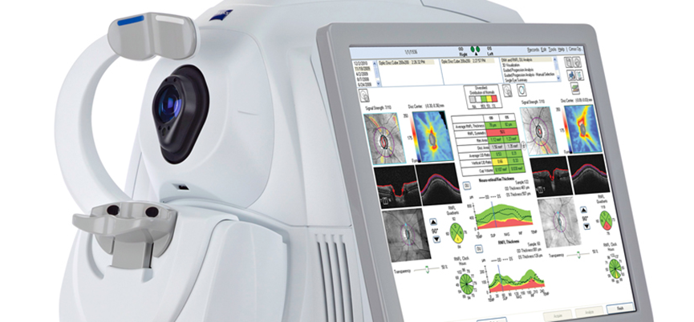

*Fig (2.3) CIRRUS HD-OCT - Optical Coherence Tomography [17]*

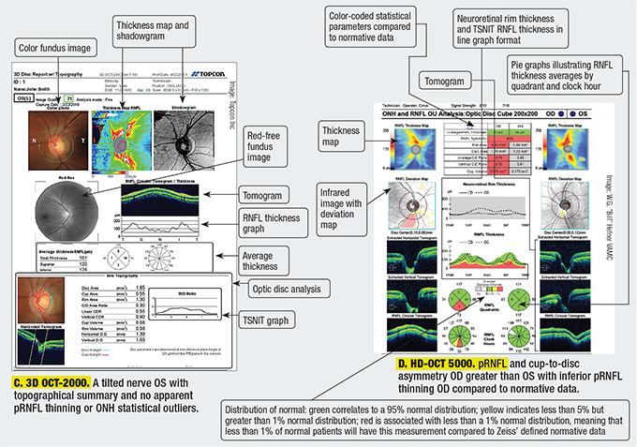

*Fig (2.4) CIRRUS HD-OCT - Optical Coherence Tomography results*

**29**

Specifications of OCT machine that used:

Table (2-2) Specifications of OCT machine [11]

|  |  |
| --- | --- |
| **OCT Imaging** |  |
| **Methodology** | **Spectral domain OCT** |
| **Optical source** | **Superluminescent diode (SLD), 840 nm** |
| **Scan speed** | **27K- 68K A-scans per second** |
| **A-scan** | **2.0 mm (in tissue), 1024** |
| **Axial resolution** | **5 μm (in tissue)** |
| **Transverse resolution** | **15 μm (in tissue)** |
| **Fundus Imaging** | **Model 5000** |
| **Methodology** | **Line scanning opthalmoscope (LSO)** |
| **Live fundus image** | **During alignment and during OCT scan** |
| **Optical source** | **Superluminescent diode (SLD), 750 nm** |
| **Field of view** | **36 degrees W x 30 degrees H** |
| **Frame rate** | **> 20 Hz** |
| **Transverse resolution** | **25 μm (in tissue)** |

**30**

**2.3- Methods:**

**2.3.1- Criteria of treatment:**

1. Thickening of the posterior capsule of the lens post to cataract surgery this lead to opacity in the visual axis of the eye causing decrease vision and contrast sensitivity of patients, visual acuity for most patient less than 6/18
2. Unclear fundoscopy when retinal examination is required such as diabetic retinopathy or other retinal diseases.

**2.3.2- Explanation to the patient:**

The patient reminded that Laser capsulotomy is a painless procedure or associated with very slight burning sensation, and has to tell the patient to expect flashes. That requires a fixed eye and steady head lasting about 2 minute. The patient has to be told not to talk or move during the laser firing period.

Also explanation of the procedure for patent in detail was done including risks, beneﬁts, signing of informed consent form. Informed consent was obtained from all patients.

**2.3.3- Pretreatment ocular examination:**

The pretreatment ocular examination included the following:

1. Visual acuity (VA) and best corrected VA (BCVA).
2. IOP measurement by Topcon CT-80 tonometer.
3. RNFL thickness measured by using ZEISS (CIRRUS HD-OCT) Advancing smart OCT
4. Slit lamp biomicroscopy for ocular surface diseases, and fundoscopy using Volk aspheric +90D non-contact lens.

**31**

**2.3.4- procedure technique:**

1. Pupil dilation with topical companied mydriatic agents: 2.5% phenylephrine or 0.5% or 1% tropicamide eye drop 30 minute prior to procedure.
2. Topical anesthesia with tetracaine hydrochloride 0.5% eye drop to reduce blinking rate.
3. Adjustment of chair, table, chin rest, and footrest for optimal patient comfort.
4. Application of head strap to maintain forehead position
5. Determination of visual axis and normal pupillary size: sketch and preliminary laser marker shot
6. Posterior defocusing of the target by 50-100 micrometer to prevent IOL pitting
7. Starting with 1mJ the minimal amount of energy necessary to obtain breakdown and rupture the capsule is desired then increasing the energy according to the result.
8. Cruciate opening Begin at 12 o'clock in the periphery, progress toward 6 o'clock, and cut across at 3 and 9 o’clock. Technique has performed.
9. Post capsulotomy topical steroid, dexamethasone 0.1% is prescribed.

**2.3.5- Laser system checking:**

The following points are checked before use:

1. The appearance of the system for any obvious deformity, dust, or disconnection of its parts.

**32**

1. The control panel of the system with standby position, energy (1 – 7 milli-Joul), pulse duration (7 Nano-second), spot size (8 micro-meter), and the aiming switch control.

C . Emergency stop switch should also be checked.

**2.3.6- Treatment tips:**

1. Applying confluent spots starting with 1 mJ and then increase the energy according to response.
2. Identify and shot across tension lines. To get maximum effect with minimum shots and energy.
3. The focusing on the IOL should be avoided to prevent pitting.
4. Monitoring IOP 3 hours post capsulotomy.

**2.3.7- Post operative follow up:**

Follow up examination were performed 3 hours post capsulotomy,one day then one month later. These steps of examinations were identical to pretreatment assessment except for RNFL thickness evaluation which was done after one month.

**2.3.8- Complications:**

Complications causing decreased vision are uncommon but include elevated intraocular pressure, CME, retinal detachment, IOL damage, endophthalmitis, iritis, vitritis, macular holes, and corneal edema. Fortunately, no serious

**33**

complication occurs in this study except elevation of IOP and sever inflammatory reaction in the anterior chamber for one patient, He was treated conservatively then get better also IOL pitting occur in one patient which was visually non-significant.

**2.3.9- laser safety in work:**

1. The laser system is placed in place where it is not exposed to the direct sunlight in the specified temperature and humidity and protected from excessive dust.
2. Labels for our laser system include the warning logotype (Danger), and description information about the laser (type, class, wave length).
3. Laser system must always be in standby mode except during actual treatment, it prevents accidental exposure if the foot pedal is in advertently.
4. As we mention previously, we start shooting with low output first and gradually increase the output in order to avoid unintentionally complications which may be produced.
5. Before operation, all the personnel inside laser room should discharged out except one assistant who should wear goggle specific for Nd:YAG laser (no need to wear eye protection device by
6. operator the optical system eye pieces design protect the operator), and even with goggle should not gaze to the laser beam directly.
7. To protect the physician’s eyes from any kind of hazardous radiation reflected from target tissue, the delivery unit has protective filter. If this filter is not set in observation path, the Laser beam cannot be emitted through the foot pedal.

**34**

1. In the case that trouble occurs in the laser system, the safety shutter automatically shuts down the optical path of Laser beam and the laser system is stopped.
2. Back reflection and scattering of laser beam prevented by black painting of the wall behind the patient.
3. We put special local air conditioner inside the laser room in addition to central one to avoid harmful effect of rising temperature above 30 °c.
4. Registration and maintenance done by specialist engineer regularly every three months.[18]

**CHAPTER THREE**

**RESULTS AND DISCUSSION**

**35**

This chapter deal with work results, related figures and tables, discussion, conclusion and recommendations for colleagues about the effects of Nd:YAG laser capsulotomy on RNFL thickness .

**3.1- Results:**

In the period of study and work (3 months) , twenty one eyes of twenty one pseudophakic patients of more than 6 months of post Nd:YAG laser capsulotomy with visually significant posterior capsule opacification .

(14-21 mmHg). No significant ophthalmic history rather than cataract surgery were documented. Fifteen male and six females, Thirteen eye had phaco surgery and only eight eyes had ECCE surgery (Table 3-1).

Table (3.1) eye distribution according to type of surgery surgery

|  |  |  |
| --- | --- | --- |
| Phaco | ECCE | **Total** |
| **13** | 8 | 21 |

**36**

Average age of the patients is 63.7 years (table 3-2) within period six months to three years post-surgery (fig 3-1). All patients had cruciate opening type of Nd: YAG laser capsulotomy.

Table (3-2) the age distribution according to sex

|  |  |  |  |  |  |
| --- | --- | --- | --- | --- | --- |
|  | 41-50 | 51-60 | 61-70 | 71-80 | Total |
| Male | 1 | 0 | 11 | 3 | 15 |
| Female | 1 | 1 | 3 | 1 | 6 |
| Total | 2 | 1 | 14 | 4 | 21 |

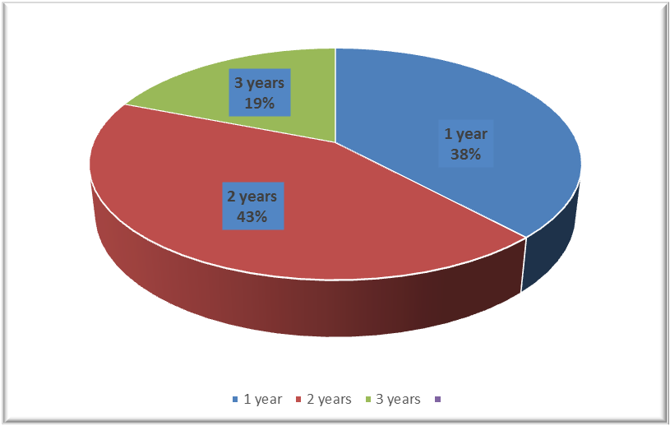

*Fig. (3-1) Post-operative period till capsulotomy*

**37**

Table (3-3) details of sample type of surgery,gender,age,pre&post capsulotomy RNFL thickness &IOP

|  |  |  |  |  |  |  |  |
| --- | --- | --- | --- | --- | --- | --- | --- |
|  | **Type of**  **cataract sugery** | **sex** | **age** | **IOP pre YAG**  **mmHg** | **RNFL**  **Thickness**  **Pre-YAG**  **Capsulotomy**  **µm** | **IOP**  **one month post YAG** | **RNFL**  **Thickness**  **1 month**  **post-YAG**  **capsulotomy**  **µm** |
| Case1 | **ECCE** | **F** | **63** | **15** | **62** | **16** | **72** |
| Case2 | **Phaco** | **F** | **42** | **18** | **93** | **18** | **95** |
| Case3 | **ECCE** | **F** | **65** | **20** | **81** | **21** | **84** |
| Case4 | **Phaco** | **F** | **55** | **16** | **97** | **15** | **108** |
| Case5 | **Phaco** | **F** | **69** | **21** | **80** | **20** | **80** |
| Case6 | **ECCE** | **F** | **73** | **16** | **80** | **16** | **83** |
| Case7 | **ECCE** | **M** | **65** | **18** | **75** | **19** | **83** |
| Case8 | **Phaco** | **M** | **69** | **16** | **100** | **18** | **109** |
| Case9 | **ECCE** | **M** | **71** | **14** | **75** | **14** | **83** |
| Case10 | **Phaco** | **M** | **66** | **17** | **87** | **18** | **92** |
| Case11 | **Phaco** | **M** | **60** | **21** | **89** | **21** | **94** |
| Case12 | **Phaco** | **M** | **62** | **15** | **88** | **17** | **92** |
| Case13 | **ECCE** | **M** | **73** | **18** | **76** | **17** | **86** |
| Case14 | **Phaco** | **M** | **64** | **15** | **90** | **16** | **92** |
| Case15 | **ECCE** | **M** | **63** | **17** | **73** | **15** | **83** |
| Case16 | **Phaco** | **M** | **74** | **14** | **86** | **16** | **100** |
| Case17 | **Phaco** | **M** | **47** | **19** | **96** | **20** | **99** |
| Case18 | **ECCE** | **M** | **63** | **21** | **71** | **21** | **81** |
| Case19 | **Phaco** | **M** | **61** | **21** | **102** | **20** | **113** |
| Case20 | **Phaco** | **M** | **68** | **17** | **96** | **15** | **98** |
| Case21 | **Phaco** | **M** | **66** | **20** | **88** | **21** | **92** |

**38**

|  |  |  |  |  |  |  |
| --- | --- | --- | --- | --- | --- | --- |
|  | Type of  cataract sugery | sex | Pre-YAG  Capsulotomy  Auto-refraction  (spherical equivalent) | One month  post-YAG  Auto-refraction  (spherical equivalent) | Pre-YAG  Capsulotomy  VA | One month  post-YAG  VA |
| Case1 | ECCE | F | **-0.5** | **-o.25** | **6/36** | **6/12 p** |
| Case2 | Phaco | F | **-0.25** | **-0.25** | **6/18** | **6/9** |
| Case3 | ECCE | F | **-0.75** | **-0.50** | **6/24** | **6/18** |
| Case4 | Phaco | F | **-0.50** | **-.050** | **6/18** | **6/9** |
| Case5 | Phaco | F | **-0.25** | **-0.50** | **6/18p** | **6/9 p** |
| Case6 | ECCE | F | **-1.0** | **-0.50** | **6/36** | **6/18** |
| Case7 | ECCE | M | **-0.75** | **-0.25** | **6/36** | **6/12 p** |
| Case8 | Phaco | M | **-0.50** | **-0.50** | **6/24** | **6/18** |
| Case9 | ECCE | M | **-0.50** | **-025** | **6/36** | **6/12 p** |
| Case10 | Phaco | M | **-075** | **-0.50** | **6/18** | **6/12 p** |
| Case11 | Phaco | M | **-0.75** | **-0.50** | **6/18** | **6/9 p** |
| Case12 | Phaco | M | **-0.50** | **-.050** | **6/18** | **6/9** |
| Case13 | ECCE | M | **-0.25** | **-0.50** | **6/18p** | **6/9 p** |
| Case14 | Phaco | M | **-1.0** | **-0.50** | **6/24** | **6/12** |
| Case15 | ECCE | M | **-0.75** | **-0.25** | **6/36** | **6/12 p** |
| Case16 | Phaco | M | **-0.50** | **-0.75** | **6/18** | **6/9** |
| Case17 | Phaco | M | **-0.50** | **-025** | **6/24** | **6/12 p** |
| Case18 | ECCE | M | **-075** | **-0.50** | **6/24** | **6/12 p** |
| Case19 | Phaco | M | **-0.75** | **-0.50** | **6/18** | **6/9 p** |
| Case20 | Phaco | M | **-1.0** | **-0.75** | **6/18** | **6/9** |
| Case21 | Phaco | M | **-025** | **-0.25** | **6/24** | **6/9 p** |

Table (3-4) details of sample type of surgery,gender, pre&post capsulotomy RNFL thickness,spherical equivalent &VA

**39**

The table ( 3-4 ) show that all patient get benefit from from Nd:YAG (1064nm) Laser capsulotomy most of them their visual acuity get two line or more from snelln’s chart.the patients were treated with phacomusification cataract surgery that was complicated to posterior capsule thickening and then treated with Nd:YAG capsulotomy,they have best visual acuity than those were treated by ECCE surgery.[22]

The RNFL thickness is show dramatic changes one month post Nd:YAG laser capsulotomy ,the average RNFL thickness pre-operative (85 μm) is increased to (106.04 μm) which represent 12% increase.this results agree with other studies.[15][16][17][18]

Phaco patients had a good results than ECCE patients regarding post Nd:YAG laser capsulotomy vision and this attributed to lesser post-operative astigmatism and better OCT signal quality .[23]

High post-operative astigmatism associated with ECCE lead to decrease OCT signal quality which leads to underestimation of RNFL thickness measurement compare to phaco surger.[24]

**40**

Fig (3-2) Average of IOP increase after Nd: YAG laser capsulotomy

*Fig (3-3) Average of RENFL thickness increase after Nd:YAG laser capsulotomy*

**41**

Table (3-5) RNFL thickness pre&post capulotomy, difference and energy applied during of Nd:YAG 1064nm capulotomy of all patients

|  |  |  |  |  |
| --- | --- | --- | --- | --- |
|  | **Pre YAG**  **RNFL**  **thickness**  **(µm)** | **Post-YAG**  **RNFL**  **thickness**  **(µm)** | **Increase in RNFL**  **thickness**  **(µm)** | **deposited**  **energy (mJ)** |
| Case1 | 62 | 72 | 10 | 100 |
| Case2 | 93 | 95 | 2 | 44.2 |
| Case3 | 81 | 84 | 3 | 52.3 |
| Case4 | 97 | 108 | 11 | 106.2 |
| Case5 | 80 | 80 | 0 | 42 |
| Case6 | 80 | 83 | 3 | 56.4 |
| Case7 | 75 | 83 | 8 | 98.4 |
| Case8 | 100 | 109 | 9 | 92.2 |
| Case9 | 75 | 83 | 8 | 102.1 |
| Case10 | 87 | 92 | 5 | 76.2 |
| Case11 | 89 | 94 | 5 | 78.2 |
| Case12 | 88 | 92 | 4 | 66.4 |
| Case13 | 76 | 86 | 10 | 98.4 |
| Case14 | 90 | 92 | 2 | 48.4 |
| Case15 | 73 | 83 | 10 | 92.8 |
| Case16 | 86 | 100 | 14 | 106.2 |
| Case17 | 96 | 99 | 3 | 48.8 |
| Case18 | 71 | 81 | 10 | 97.6 |
| Case19 | 102 | 113 | 11 | 102.3 |
| Case20 | 96 | 98 | 7 | 86.2 |
| Case21 | 88 | 92 | 4 | 52.4 |

**42**

Table (3-5) show that RNFL thickness, pre and one month post treatment in relation with energy applied the increasing in values of RNFL thickness post treatment is proportionate with total laser energy applied and this is due to thickness of posterior capsule itself since in thick capsular fibrosis when less transmission of light occur leading to underestimation of RNFL thickness.So need more energy to preform capsulotomy.[26]

The increasing value in RNFL thickness post Nd:YAG laser capsulotomy is proportionate with the total energy applied and this is due to capsule thickness itself.In dense posterior capsule opacification light transmission is affected with light reflection from the retina,underestimation will result and high energy will needed to open the capsule.[27]

**3.2- Discussion:**

**3.2.1- Age and sex of the patients:**

From the results of table ( 3-2 ),the age of patients 42 to 73 years high percentage of patients were treated within ( 61-70 ) age group. the high number of male patient in this study this increase occur by chance.there is no significance effect for age or sex on the measurement of RNFL thickness post Nd:YAG laser capsulotomy.[28]

**3.2.2- Intra-ocular pressure effect:**

All patients have IOP within the normal range after one month duration post treatment with Nd: YAG 1064 nm laser,so there is no significance effect for

**43**

IOP on the measurement of RNFL thickness post Nd:YAG laser capsulotomy.[29]

**3.2.3 Period of PCO post Cataract surgery:**

Fig( 3-1 )shows the Period separated post Nd:YAG laser capsulotomy from Cataract surgery. About (45%) of patients with period ( 13 to 24 months) and a lowest percentage(15%) in those having period (25 to 36 months). There is no significant effect on the RNFL thickness post Nd:YAG laser capsulotomy.

**3.2.4- Effect of type cataract surgery on RNFL thickness, post Nd:YAG 1064nm laser capsulotomy treatment:**

Comparison between pre and one month post procedure there is changes in values of RNFL thickness according to type of surgery,The average of RNFL thickness of patient treated with ECCE show that pre-operative average (74.125 μm) increased to (81.87 μm). The average of RNFL thickness of patient treated with phacoemulsification show that pre-operative average (91.69μm) increased to (97.23μm). there is no significant that phacoemulsification cataract surgerybetter than ECCE surgery.[2][3][28]

**3.2.5- Effect of Nd:YAG 1064nm laser energy capsulotomy treatment on RNFL thickness,:**

Tables 3-4 and 3-5 show that the Nd: YAG 1064 nm laser is effective in treatment of PCO (100%) of patient have better of VA and (100%) of

**44**

patient have IOP within the normal range after one month duration post treatment with Nd: YAG 1064 nm laser. Also improvement of RNFL

thickness values (96%) post treatment with minimal or no complications. [1][2][3][4]

Different value of laser energy was used according to PCO thickness. Total

Deposited energy recorded by multiplying number of shots with pulse energy (table 3-3). Significant of used high Laser energy to treat part of patients due to thick fibrosis of posterior capsule will need more Laser energy than other to open it. This result is similar to results of many studies done in different centers on different times and all of them recommend the use of minimal energy in laser capsulotomy to minimize IOP spike.

**3.3- Conclusions:**

**A-**The evaluation of RNFL thickness by using OCT influences by presence of posterior opacification this lead to underestimation of RNFL thickness.

**B**- Nd:YAG 1064nm laser capsulotomy used for treatment for post cataract surgery posterior lens capsule opacification.the energy of laser deposited is proportional tp the thickness of PCO.so for need more Laser energy to open thick capsule.

**C-**Nd:YAG 1064nm laser capsulotomy is effective in improving visual acuity post cataract surgery posterior lens capsule opacification.

**D-** Close follow up is essential for patients treated with Nd:YAG 1064nm laser capsulotomy to decreased effect of complications like spike IOP elevation.

**45**

**3.4 Recommendations**

Nd: YAG 1064nm laser capsulotomy is effective and safe treatment for post cataract surgery posterior lens capsule opacification. The OCT imaging is new diagnostic device so we need to do more studies to improving the effects of Nd:YAG 1064nm laser capsulotomy.the following important facts for future studies

1. The RNFL thickness must be documented before cataract surgery for more accuracy
2. The type and design of IOL must be included in future study because their optical effects on the OCT signal.
3. The using the OCT for measurement the thickness of PCO in the future studies may decrease complications of Nd:YAG 1064nm laser capsulotomy by decreasing the Laser energy deposited to the eye
4. The assessment period was short .I need more time to study by

Re-measurement of RNFL thickness each 6 months for at least period of 18 months need to assessment of effect of Nd:YAG 1064nm laser capsulotomy effect on RNFL thickness

1. Study the effect of refractive errors on measurement of RNFL thickness by OCT the LASIK candidates are our target.

**46**

**References:**

1. James, Bruce, Lecture notes on ophthalmology.—9th ed.2003 ISBN 1-4051-0714-6,p 1,2,3
2. LEE ANN Remington, CLINICAL ANATOMY OF THE VISUAL SYSTEM,2nd edition 2005,ISBN 0-7506-7490-3,p 55-58
3. Kanski, Clinical Ophthalmology a systematic approach 8th edition,2016, ISBN: 978-0-7020-5572-0,p 293-294
4. Daniel Albert Joan Miller ,Albert &Jakobiees.priciple and practice of ophthalmology,3rd edition,2008, ISBN: 9781437721119,vol 1,chapter 121.
5. CIRShetal M. Raj, Abhay R. Vasavada, Post-Operative Capsular Opacification, Int J Biomed Sci. 2007 Dec; 3(4): 237–250.
6. Atul Kumar,Laser in ophthalmology a practical manual,2nd edition,2005,ISBN81-8061-553-8,p88-92
7. Svelto, Orazio, Principles of Lasers,5th edition,2010, ISBN 978-1-4899-7713-7,p1-15
8. Paras N. Prasad, Introduction to Biophotonics,2003, ISBN 0-471-28770-9,p129-135
9. RighabHamdan, Ricardo GarciaGonzalez,Optical coherence tomography: From physical principles to clinical applications, Volume 105, Issue 10, October 2012, Pages 529-534
10. Brett E Bouma, Seok-Hyun Yun, Fourier-domain optical coherence tomography: recent advances toward clinical utility, Curr Opin Biotechnol. 2009 Feb; 20(1): 111–118.
11. Carl Zeiss Meditec AG, cirrus HD-OCT 5000 user manual. EN_31_010_0014I,p6

**47**

1. M.H.Niemz Markolf ll. Nemz M.H. Laser tissue interaction. University of Heidelberg-Germany, Third edition 2003; 70-110.
2. Gonzalez-Ocampo-Dorta S, Effect of posterior capsular opacification removal on macular optical coherence tomography. Euro J .Ophthalmol. 2008 May-Jun; 18(3):435-41.
3. Jose Javier Garcia-Medina, Does Posterior Capsule Opacification Affect the Results of Diagnostic Technologies to Evaluate the Retina and the Optic Disc, Biomed Res Int. 2015; 2015: 813242.
4. Cagini C1, Pietrolucci F, Lupidi M, Messina M, Influence of pseudophakic lens capsule opacification on spectral domain and time domain optical coherence tomography image quality. Curr Eye Res. 2015 May;40(6):579-84.
5. Selim Cevher1 ,Yusuf Koçluk, Short-term effect of Nd:YAG laser capsulotom on refraction, central macular thickness and retinal nerve fiber layer thickness, Rev Bras Oftalmol. 2017; 76 (4): 186-9
6. OPERATOR’S MANUAL TO NIDEK YC-1300/1400, 2003. 09,17142-P9A2A,p7-1
7. David H. SlineyStephen L. Trokel, Medical Lasers and Their Safe Use,1993, ISBN978-1-4613-9254-5,p30-66
8. Jose Javier Garcia-Medina, Does Posterior Capsule Opacification Affect the Results of Diagnostic Technologies to Evaluate the Retina and the Optic Disc, Published online 2015 Jun 8. doi: 10.1155/2015/813242
9. José Javier García-Medina, Effect of posterior capsular opacification removal on scanning laser polarimetry measurements, Graefe's Archive for Clinical and Experimental Ophthalmology

**48**

1. Necip Kara, Hasan Altinkaynak, Effects of posterior capsular opacification on the evaluation of retinal nerve fiber layer as measured

by stratus optical coherence tomography, Canadian Journal of Ophthalmology, Volume 47, Issue 2, April 2012, Pages 176-180.

1. Mohamed El-Ashry , The Effect of Phacoemulsification Cataract Surgery on the Measurement of Retinal Nerve Fiber Layer Thickness Using Optical Coherence Tomography, JournalCurrent Eye Research Volume 31, 2006 - Issue 5,p409-413
2. Ari S., Cingü AK, Sahin A, Çinar Y, Çaça I. The effects of Nd:YAG laser posterior capsulotomy on macular thickness, intraocular pressure, and visual acuity. Ophthalmic Surg Lasers Imaging. 2012 Sep-Oct;43(5):395-400.
3. Goble RR, O'Brart DP, Lohmann CP, Fitzke F, Marshall J. The role of light scatter in the degradation of visual performance before and after Nd:YAG capsulotomy. Eye. 1994;8(Pt 5):530–534.
4. Apple DJ, Solonom KD, Tetz MR, Assia EI, Holland EY, Legler UF, Tsai JC, Castaneda VE, Hoggatt JP, Kostick AM. Posterior capsule opacification. Surv Ophthalmol. 1992;37(2):73–116.
5. Gregor Hawlina, Darko Perovšek, Optical coherence tomography for an in-vivo study of posterior-capsule-opacification types and their influence on the total-pulse energy required for Nd:YAG capsulotomy, BMC Ophthalmol. 2014; 14: 131
6. Rahul Bhargava, MS,1 Prachi Kumar, MD, Neodymium-Yttrium Aluminium Garnet Laser Capsulotomy Energy Levels for Posterior Capsule Opacification. J Ophthalmic Vis Res. 2015 Jan-Mar; 10(1): 37–42.

**49**

1. Hu CY, Woung LC, Wang MC. Change in the area of laser posterior capsulotomy: 3 month follow-up. J Cataract Refract Surg. 2001; 27(4):537–542.
2. C.N. Chua et al, Refractive changes following Nd:YAG capsulotomy. Eye (2001) 15, 304--305 © 2001 Royal College of Ophthalmologist.

**الاستنتاج:-** ان استخدام ND:YAG 1064 نانومتر ليزر في علاج عتمة الغشاء الخلفي لعدسة العين علاج فعال وامين .

ان قياس سمك طبقة الالياف العصبية لشبكية العين باستخدام جهاز الاو سي تي يتأثر بوجود عتمة الغشاء الخلفي للعدسة مسببا عدم الدقة في قياس السمك الحقيقي لهذه الطبقة وانما اعطاء سمك اقل من السمك الحقيقي لهذه الطبقة

**خلاصة البحث**

**اسم البحث:-** تقييم سمك طبقة الالياف العصبية لشبكية العين باستخدام بجهاز التصويرالمقطعي بالحزمة الضوئية المشاكهه((OCT بعد معالجة عتمة الغشاء الخلفي للعدسة بجهازND:YAG ليزر 1064 نانومتر

**الدراسة:-** تناقش التغييرات التي تطرأ على طبقة الالياف العصبية لشبكية العين بعد علاج عتمة الغشاء الخلفي للعدسة باليزرالموضعي من خلال قياس سمك هذه الطبقة بوجود العتمة وبعد ازالتها بأستحدام الليزر . باستخدام جهازالتصوير المقطعي باستخدام الحزمة الضوئية المتشاكهه (OCT)

شملت الدراسة 21 عيناً ل 21 مريضاً,15 مريضا من الذكور و6 من الاناث جميعهم سبق وان اجريت لهم عملية رفع الساد اما بطريقة التقليدية او بطريفة الفاكو وقد جرت الدراسة للفترة من منتصف حزيران /2018 الى منتصف ايلول/2018 في مستشفى الحبوبي التعليمي / في مدينة الناصرية .

**النتائج:-** كانت النتائج هي تحسن الرؤيا لجميع المرضى مع استقرار ضغط العين ضمن الحدود الطبيعية لمعظمهم.وقد سجلت الدراسة زيادة في سمك طبقة الالياف العصبية لشبكية العين وذلك عند تقييم سمك هذه الطبقة بعد شهر من اجراء المعالجة بالليزر واتضح الى ان السبب يعود الى تأثير عتمة الغشاء الخلفي للعدسة على نتائج الفحص بجهاز الاو سي تي( OCT ) حيث اتضح وجود العتمة يسبب قرأة سمك اقل من السمك الحقيقي لهذه الطبقة وجاء ذلك مطابقا لنتائج الدراسات التي سبق وان تم اجراؤها بنفس الموضوع.كما سجلت الدراسة ان سمك الغشاء الخلفي المعالج بالليزر يتناسب طرديا مع الطاقة المستخدمة بالعلاج ولوحظ ان نوع الجراحة عامل مؤثر في قراءة سمك الطبقة العصبية لشبكية العين حيث ان قياس هذه الطبقة يكون ادق في العين التي سبق وان تم ازالة الساد بطريقة الفاكو (phaco)بالمقارنة بالطريقة التقليدية (رفع الساد بطريقة خارج الغشاءECCE )بسبب وجود الخطأ الانكساري المؤثر بالطريقة الاخيرة.

**وزارة التعليم العالي والبحث العلمي**



**جامعة بغداد**

**معهد الليزر للدراسات العليا**

**تقييم سمك طبقة الالياف العصبية لشبكية العين باستخدام بجهاز ال OCT بعد معالجة عتمة الغشاء الخلفي للعدسة بجهاز YAG ليزر**

**دراسة**

**مقدمة الى معهد الليزر للدراسات العليا-جامعة بغداد**

**كجزء من متطلبات نيل شهادة الدبلوم العالي في تطبيقات الليزر في طب العيون**

**إعداد**

**د.حسين جاسم عبد الخفاجي**

**بورد عربي طب وجراحة العيون**

**بأشراف**

**المدرس الدكتور**

**احمد محمد حسن**

**بورد عربي طب وجراحة العيون/ دبلوم ليزر**

**1440 هجري ميلادي 2018**